lOMoARcPSD|12546940

NOTES

lOMoARcPSD|12546940

1 Lecture Notes CS – Intro

- Aims of security

Confidentiality Integrity

Availability Authenticity

Non-Repudiation

- Confidentiality

Certain information must be kept secret from unauthorised access. Importance of confidentiality

o Loss of revenue

o Loss of reputation

o Loss of clients/customers

    - Embarrassment

    - You may be in breach of a legal/moral/ethical obligation to keep information confidential

Ensuring confidentiality

    - Encryption

    - Access Control

- Integrity

ensures that information and systems have not been altered in an unauthorised way Breaches

    - Malfunctions

    - Unauthorised changes

      - People

      - Malware

Ensuring integrity

    - Regular backups

    - Checksums

    - Data correcting codes

- Availability

information or systems are accessible and modifiable in a timely fashion by those authorized to do so

lack of availability is often referred to as a denial of service.

- Authenticity

Verification of claim

- Non-Repudiation/Accountability

- Statistics on computer abuse

Attacks may never be detected Attacks may never be reported Difficulties in quantifying loss.

- Security is difficult to sell

Management may ask

    - What does it cost?

    - What do we get?

    - How much will it cost to maintain?

lOMoARcPSD|12546940

o Will we need to train our staff?

9. Ethics and legal issues

Lecture Notes CS – Threats & Threat Agents

- What is a threat

A possible danger

- Vulnerabilities

A flaw or weakness in the design, implementation or operation of a system How open something is to an attack

Threats act on or exploit vulnerabilities.

The possibility of being attacked or harmed.

- Risk control

Defence

Mitigation Acceptance Transferal Termination

- Instinctive risk assessment

Risk assessment is instinctive on a day to day basis

We autonomously assess the risk involved with everyday life

- Real vs Perceived risk

- Generic Threat Categories Interception

o Unauthorised entry

Modification

o Breach of integrity

o Data, structure, OS

Fabrication

o Creating new information within a system

Interruption

o An asset is lost, unavailable or unusable

o Breech of availability

o Physically destroying hardware

o Erasing programs or files

o Disconnecting a power or network cable

- Specific Threats Intrusion Hacking

o For specific gain

o As a job

Espionage

o Obtaining information in a secretive manner

o Via network or system intrusions

o Dumpster diving

o Social engineering

- “hi im Calling from IT…”

lOMoARcPSD|12546940

Destruction of hardware Destruction of software Destruction of data

Hardware theft Software theft Data theft

Injection of traffic/data Corruption of data

Eavesdropping/Surveillance

o Electronic o Optical

o Profiling of web browsing habits Social engineering

Malware

o Malicious + Software = malware

Information Warfare

o Misuse of information of gain an advantage

- Threat agencts/attackers

The source of these threats Examples

o Malware writers

    - Hackers

    - Fraudsters

    - White collar criminals

    - Organised crimes

    - Governents

- Motivations of attackers Financial

Emotional Ideological Opportunity Compulsion

- Capabilities of attackers

Organised/disorganised Individual/group

Resources

- Risk Aversion

How risk adverse is the attacker

Does the attacker fear being caught?

- Threat modelling

Attack trees

    - Used to model threats on a given asset

    - Graphical representation of the way that we can attack an asset. One to many relationship

    - Always has to go to multiple options

    - One will not work

lOMoARcPSD|12546940

- Controls and Safeguards Prevention

    - Firewalls

    - Security gurads

    - Passwords

    - cryptography

Detection

    - Security guards

    - Log file analysis

    - Intrusion detection Systems Responsive

    - Law enforcement

    - Forensic analysis

- Determining appropriate control Depends on context

    - Environmental

    - Situational

Lecture Notes CS – Malware

- What is malware

Software designed to infiltrate, damage or disrupt a computer system without the owners informed consent

- Consequences

Steal your personal info

Monitor computer activity

Used to install additional software Display forced advertising

Enable profiteering scams

Use your computer resources

- Evolution of malware 90’s

o Hack against web servers

o To prove you are a skilled hacker ect

2000

o Monetary value can be established at the same time

- Malware explosion

As more devices are being used ect… more people are developing malware from it

- Why does a system become vulnerable to malware Flaws or bugs in software

Over privileged users or system processes Design of software or a system

Poorly implemented Standard Operating Environment (SOE) practices

- Malware specimens

Zeus Trojan horse

lOMoARcPSD|12546940

o Toolkit (can specify what the malware does)

o Commonly spread by FaceBook messages

  - Installed via drive-by-downloads and phishing

  - Works on Microsoft Windows only

  - Attacker fine tunes their Trojan to steal information of interest to them only

  - Awakes when a particular site is accessed

Psyb0t

  - Targets Linux based ADSL routers

  - Infection occurs from an internal IP address

  - Initially pre-populated with 6000 usernames and 13,000 passwords

  - Generally exploits poorly configured devices

  - When part of a botnet is receives commands via IRC command and control servers

- Classifying malware Propagation

o How it moves through devices/networks ect

Concealment

o Self hiding

o Provide desirable functionality

Payload

o What is caries/functionality of the program

- Viruses

Can infect other programs by modifying them Phases

- Dormant

  - Waiting of trigger event

- Propagation

  - Replicating to programs/disk

- Triggering

  - By event to execute payload

- Execution

  - Of payload

Types

o File virus

- Infecting a highly used program i.e. a game or operating system files

will result in continuous re-infection and propagation o Macro virus (macro language)

- Infects files with macro code

- Commonly infects MS Office documents

lOMoARcPSD|12546940

o Boot sector virus

- Infects the code in the boot sector of hard disk o Encrypted virus

- Payload and replication mechanism is encrypted

- Virus = decryption engine + encrypted body

- Encryption remains the same throughout the life of the virus o Stealth virus

- Hides itself from AV detection

- May copy data from non-infected files to itself to avoid detection o Polymorphic virus (change appearance of)

- Mutates with every infection

- Changing encryption/decryption keys

- Data appending / data pre-pending

o Metamorphic virus

- Mutates and rewrites itself with every iteration

- Adding useless instructions and loops

- Worms

Spreads without needing to insert itself into other files and usually without human interaction

Most worms spread by exploiting vulnerabilities or poorly configured systems Firewalls can be used

Worm Propagation

o Scan for targets on network

o Locate a target with a vulnerability that could be exploited by the worm o Exploit the identified vulnerability and establishes itself on that host o Repeats the process by scanning for new targets that can be exploited

- Trojan horses

Appear desirable but have malicious content within Types

o Simple / ‘classic’ Trojan horse

- A calculator program that looks and acts as a calculator, but every

time the 7 button is pressed it deletes a random file from the hard drive

o Remote access Trojan horse

- A backdoor into a system and allow an attacker to execute or

monitor actions on the victim’s computer o Indirect Trojan horse

- Use infected computer to launch attacks

- Root Kits

And application designed to hide the fact that an operating system has been infected Three components

- Concealment

lOMoARcPSD|12546940

o Command and control

o Surveillance

Run on infected device with admin/root access

May alter/hide security settings, process, files, system drives, network ports and system services

Can typically be removed with AV software but (some) damage to the system may be unrepairable

Types
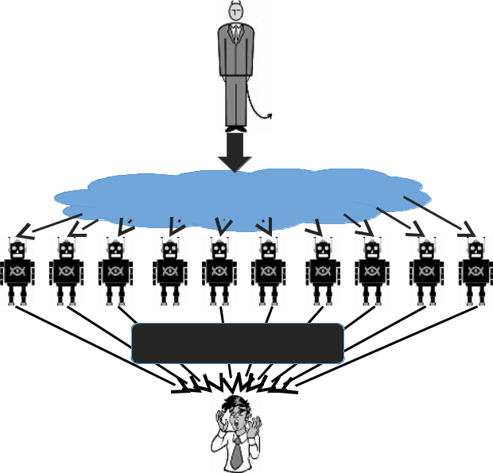
o Kernel mode
o Firmware rootkits
Botnet Controller
12. BotNets
Malware that turns host into a zombie^{(Attacker)}
A zombie is a machine controlled by a master

13. Logic Bomb

Attack
Commands

Bot | Attack Actions
net: | Attack Actions

Performs a malicious action as a result of a logic condition
Example _{Vic}
o A programmer puts code into software for the payroll system that makes the
tim

program crash should it ever process two consecutive payrolls without paying him

- Spyware

Spys on everything you do and records information

- Adware

Spyware but then sends specific ads to computer

- Ransomware

Kidnaps computer and charges to remove it Locks files, computer, sectors ect

- Scareware

Scars you into thinking that your computer is compromised or has done something wrong

- Countermeasures Signatures

o Each malware specimen is unique

o Sometimes false positives occur

Shield vs on demand scanning o Shield

  - Background process

  - Scans when a file is touched o On demand

  - Scan on explicit user request or according to a regular schedule

  - Scan on a specific type of a file program ect

lOMoARcPSD|12546940

Lecture Slides CS – Crypto 1

- Terminology

Encryption

o Used to establish confidential communication over an insecure channel

Cipher

o An algorithm used to encrypt

Plaintext

o The original readable message

Cipher text

o The encrypted message

Cryptography

o The creation or development of encrypting or decrypting data

Cryptanalysis

o The study of breaking encryption

Cryptology

o Combination of cryptography and cryptanalysis

Codes

o Replacing a phrase or message with a word or symbol o ‘Be right back’ = BRB

Ciphers

o Replacing individual characters, digits or bits

o ‘Be right back’ = cf sjhiu cbdl

Caewsar Cipher o Basic

o Only 26 possibilities
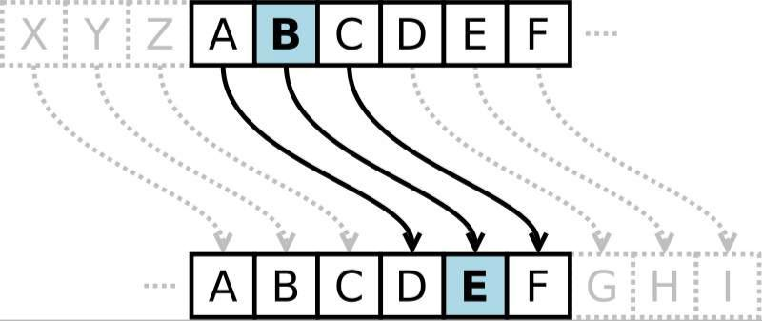

2. Ciphers categorised
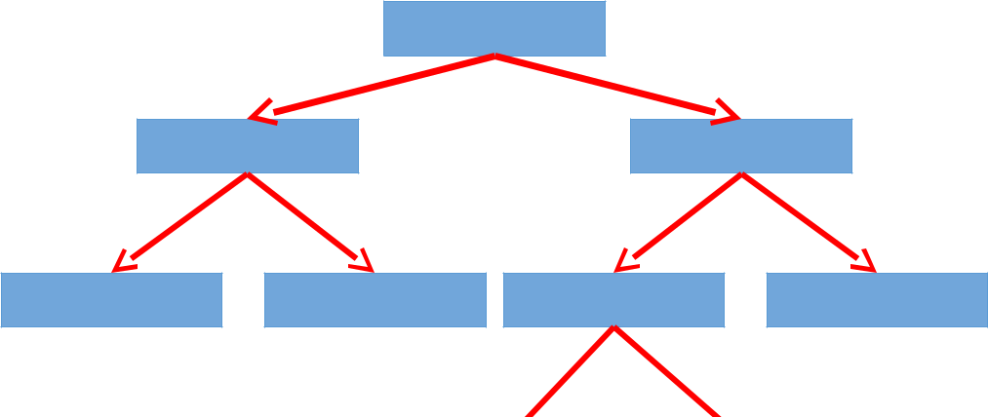

Ciphers

Classical

Modern

Substitution

Transposition

Symmetric

Asymmetric


lOMoARcPSD|12546940

Stream Block

- Systematic Encryption

Sender>encrypt>shared secret key>cipher text>Shared key>Decrypt>receiver Key distribution can be a problem

- Asymmetric Encryption

Utilises a private key and a public key Private Key

o Must be kept secret

Public Key

o Can be given to the public

- Block ciphers

Plain text/ciper text have a fixed length

Breaks up into a certain number of blocks

- Stream Cipher

Symmetric cryptosystem where cipher text C is obtained as the exclusive OR of the

plaintext message M and a pseudo-random binary vector S generator from the

secret key Message>▼

Seed>keystream generator>key stream > XOR cipher text

- Symmetric Block ciphers

Data Encryption Standard (DES)

o Developed by IBM in 1977

o 64 bit blocks, 56 bit keys

Triple DES (3DES)

o Effective key length of 168 bits

o Tried to resurrect DES, but computationally inefficient

    - Cipher text = E_{KC}(D_{KB}(E_{KA}(P))) Advanced Encryption Standard (AES)

    - Selected by NIST in 2001 through open international competition and public discussion

    - 128-bit blocks

    - 128, 192 and 256 bit key lengths

    - Exhaustive key search attack is not currently possible

- Symmetric Stream Cipher RC4

    - Rivest Cipher 4 designed by Ron Rivest from RSA Security in 1987

    - Used in SSL and WEP

    - Simple and computationally efficient

    - Key sizes range from 40 – 2048bits

RSA

    - Designed by Rivest, Shamir and Adelman (RSA)

    - It is easy to multiply 2 numbers and calculate a product, but difficult to take a product and determine all of its factors

    - Usually deals with very large prime numbers

Badar M

lOMoARcPSD|12546940

o Common key lengths are 512, 1024, 2048 or even 4096 bits

- Steganography

Hiding data within a picture

Lecture Notes CS – Data Integrity

- Parity Bits

2 Check sums

3 Cryptographic Hash Functions

Complex mathematical algorithm Examples

    - MD4 ,MD5

    - SHA1, SHA256, SHA512

    - RIPEMD160

    - PANAMA

    - TIGER

    - And many others MD5

    - Developed by Ron Rivest in 1991

    - Outputs 128 bit hash values

    - Widely used in legacy applications

    - Considered academically broken

    - Faster than SHA-1 Sha-1

    - Developed by NSA and approved by NIST

    - Outputs 160 bit hash values

    - Contains less implementation issues than MD5 (as it should!)

    - Is computationally more intensive than MD5

    - Superseded by the SHA-2 family

    - SHA-256, SHA-384 and SHA-512

- Hash function

Common uses include

    - Digital signatures

    - Intrusion detection systems

    - Secure communications protocols

    - Storage of passwords

    - Verifying that evidence has not been tampered with Collisions

    - When two entirely different digital objects produce the same hash output

    - Hash function collisions are a negative trait

    - Hash algorithms must have a very low collision rate

    - The probability that two objects happen to result in the same digest value is so small that it is not even worth considering

    - The results of hash functions are routinely used in a court of law to prove that two binary objects are identical

HMAC

lOMoARcPSD|12546940

- MACs are Message Authentication Codes

- HMACs combine hash functions and secret keys to not only provide integrity but also authenticity

- Instead of just taking the object as an input to the hash function, a HMAC or keyed hash function also takes a symmetric key that is typically not shared.

- Basically a password for your hashing values

- DIGITAL Signatures

Sender uses signing algorithm to sign message Message and signature are sent to the receiver

The receiver receives the message and the signature and applies the verifying algorithm to the combination.

If the result is true, the message is accepted; otherwise it is rejected

- Digital Certificates

09.02 Week 6 Lecture Notes CS – Identification & Authorisation

- Identification

Establishing who you are

- Authentication

Establishing that the entity is actually who they say they are Mordern tech uses multi factor authentication

- Authorisation

Establishing what the entity is allowed to do

- Notes

Different techs can be used for authentication or identification or both

- 3 approaches

Something you know

    - Password

      - Most commonly used

    - Answers to questions

    - usernames Something you have

    - Id card

Something you are

    - Biometrics

- Password attacks often occur off-line using (off line means lifting the hast data base to an external system to test against to eliminate the limit on the number of tests you can perform)

Dictionary attacks Brute force attacks Hybrid attacks

    - These can be very computationally intensive

    - An i7 processor can crack most passwords quite quickly

    - What about a cluster of computers?

    - What about a GPU? Or a cluster of GPUs?

- Password Salts

A random collection of characters added to a the start of end of a pass

lOMoARcPSD|12546940

Stored in plaintext

Increases the size of the password

- Biometric scanning Fingerprint Eye scan Photo

Voice

keystrokes

Walking style (gait analysis) Two types of errors

o False acceptance

  - Scan accepts the wrong person o False rejection

  - Scan fails to recognise the correct person

Problems

o To many variables that can change that would influence the reliability of a scanner

Lecture Notes CS – Hardware & Data Security

- Early Computers

Security issues were hardware issues

Security was controlled by physical access control to the room

- Modern Computers Mobile

Interconnected

Multi functioning

- BYOD

Use of personal devices for work purposes

Essential company data is now stored on pers devices

- Threats Against Hardware Theft

Environmental

Physical Destruction Accidental damage Loss/misplacement Hardware age/stress

Theft of hardware to steal the data inside

- Environmental Threats Electricity

o Spikes of electricity can cause damage to digital services o Equipment requires steady uninterrupted power supply

Water/ACTs of God o Flood

o heatwave

- Physical Destructions

Hardware could be damaged deliberately or accidentally

Backups are the #1 means to resolve destruction based issues

lOMoARcPSD|12546940

Access control

Redundant computers/servers/equipment

- Hard ware theft remedies

Microdot technology RFID tagging

CCTV monitoring

Access card control

Physical storage of portables Data at rest encryption

Mobile device tracking

- Ellectrical issue mitigation strategies Uninterrupted power supply

o Provides instant power

o Battery backup for constant power

o Encompasses power surge/spike protection

- Hard ware encryption

Provides constant encryption for all data

Hard drives could be encrypted/decrypted on the fly by main-boards or by dedicated cards

- Data Storage

Data is stored on 1 sector at a time A sector is typically 512 bytes

Exam Overview

Will be asked about real world examples

Which part of the security is breached o Confidentiality

o Availability o Integrity

o Authenticity

o Non-repudiation/accountability

- How would you convince them to purchase, apply and use security Scare tactics

lOMoARcPSD|12546940

Consequences

o Relevant to their context/situation

Use of statistics

o Frequency of attacks being carried out to similar business/individuals

Demonstrate ease of use of new system o Simplicity

- Understand security Threat

Risk

Vulnerabilities

- Types of threats

Real vs perceived

- Generic threats

Interception/disclosure Modification

Fabrication Interruption

- Attack tree

30 nodes Specific

Naming of tools/programs

- Malware

Types

  - Trojan

  - Worm

  - Ransomware

  - Virus

  - Scareware

  - Rootkit

  - Botnet

Make a table Devise criteria

Comparison table

  - Distribution

  - Infection types

  - Purposes

  - Weaknesses

  - Outcomes

  - Consequences


 | Propagation | Concealment | Payload
Trojan | Acts like | Acts like legitimate program | Remote
 | legitimate |  | access,
 | program |  | monitorin
 |  |  | g, file
 |  |  | deletion
Worm | Scan, locate |  | File
 | vulnerability, |  | deletion or

Downloaded by Badar Mohamed (mohabadar@gmail.com)

lOMoARcPSD|12546940


exploit, backdoor

repeat creation

RansomWar

e

Virus Replicates to Encrypted/Stealth/polymnorphic/metamorphi programs/dis c/
k
Scarware
Rootkit Can be kernel or firmware rootkit Provide

access to
admin

/root
access

- Codes vs cyphers

Asymmetric

o Public key and private key

Symmetric

o Singular key used to encrypt the data

Strengthes and weaknesses comparison table o Third party server

o Technical skills

Draw a diagram Draw a table

Digital signature process Certifying authorities

Digital certificates

o Used to provide authentication of a public key

o What are the key components

- Biometrics

3 examples of

- Authorisation

  - What a user is allowed to do by the system

- Identification

  - Username

  - Fingerprints

▪

- Authentication

- Password

▪

How to hack crack passs

o How would you lift from win os

o What is the tech approach to cracking the pass

o Pwdump>dump pass hashes > john the ripper > crack station

Physiological vs behavioural o Difference and types

lOMoARcPSD|12546940

- File systems

Fat32 vs ntfs

o Which is more secure

Windows nt logon process o Module 8

o Use graph

- Open source vs commercial software Which is better

What is shell code Open source

o Develops cant hide things

o Open to more scrutiny

Commercial

o Financial incentive

o Pubic scrutiny

o Support structure

Would you trust open source or commercial encryption software o Depends on the complexity of the key??

- Networks

Dif between IPv4 and IPv6 IPv4

o 32-bit numeric address (IPv4) is written in decimal as four numbers separated by periods.

o IPv6 addresses are 128-bit IP address written in hexadecimal and separated by colons.

o

Network scanning/recon tools Wired vs wired networking

o Pros and cons

Exam Notes – possible questions

- Aims of security

Confidentiality Integrity

Availability Authenticity

Non-Repudiation

- THREAT TREES

Threat trees will be in the exam Will be worth 20% of the exam

Getting a password for a computer login

lOMoARcPSD|12546940

o No Password

- Password

  - Crack (software) Online Offline

Brute force

Brutus program

Dictionary attack

Hash each word and compare to

password hash

Rainbow tables

Backwards engineers crypto function

Rainbowcrack program

Character Set

A defined type of characters

EG 2 numbers the a 5 letter word…ectk

Key logger0

- Social Engineering Bribe
Pay money

Blackmail

Obtain incriminating evidence

Threaten

Physical

Job opportunity

Social life

Steal

Find written copy

Use cameras to record screen

Espionage

Cameras

Audio recording

Drug

- Malware (7 types) RAT

o Remote Access Trojan

- A backdoor into a system and allow an attacker to execute or monitor actions on the victim’s computer

Trojan Worm

Ransomware Virus

Scareware Rootkit

Botnet

lOMoARcPSD|12546940

- Encryption

Which is more trustworthy

o Commercial or open source

    - Freeware

    - Shareware

    - Government backdoors

    - Master decryption keys

- 3 approaches to identification and authentication Something you know

    - Password

      - Most commonly used

    - Answers to questions

    - usernames Something you have

    - Id card

Something you are

    - Biometrics

lOMoARcPSD|12546940

